**LAB 04**

**TASK 01:**

<https://leetcode.com/problems/middle-of-the-linked-list/submissions/1392804684?envType=problem-list-v2&envId=linked-list>

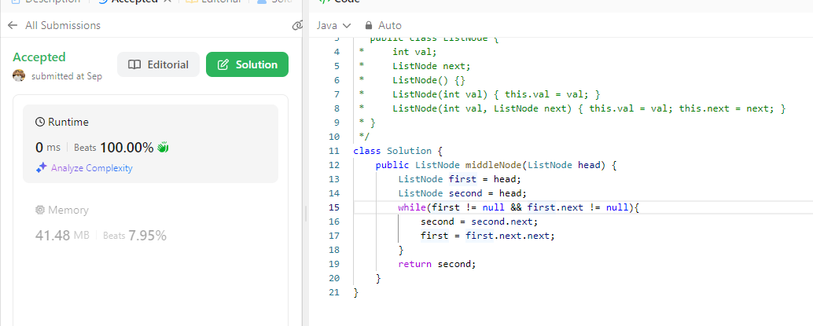

**TASK 02:**

<https://leetcode.com/problems/convert-binary-number-in-a-linked-list-to-integer/submissions/1392814458?envType=problem-list-v2&envId=linked-list>

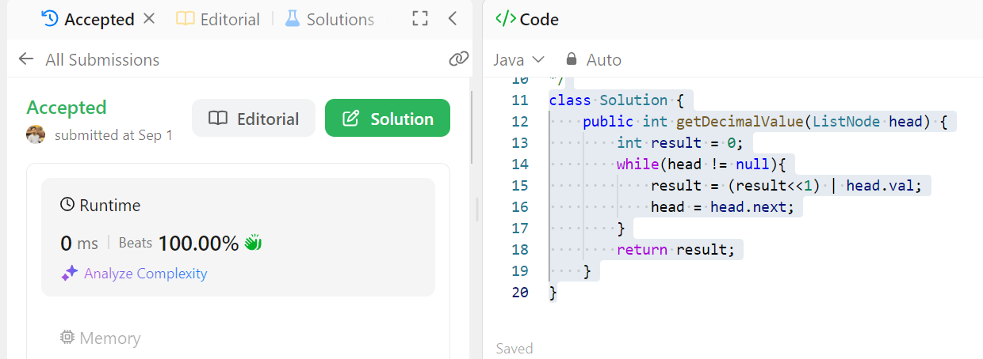

**TASK 03:**

<https://leetcode.com/problems/add-two-numbers/submissions/1392817633?envType=problem-list-v2&envId=linked-list>

